УДК 621.757;657.621.882.082.8

Ugbabe Ediga, Danylova L.
National Technical University of Ukraine «Kyiv Polytechnic Institute», Kyiv

Analysis of the pattern of plastic deformation of the thread

Thread forming screws have a trilobular thread pattern which forms a thread during insertion. Thread forming screws, also knows as thread rolling screws, do not require the hole to be tapped before insertion as they tap their own thread during assembly. The trilobular thread pattern reduces friction during thread forming, provides a greater level of prevailing torque than alternative locking fasteners, and perhaps most importantly, provides excellent anti-vibration resistance. Thread forming screws are available in a variety of head types including hexagon head, pan head and countersunk head.
When you install the screw into the workpiece appearances on the faces of the intake cone gradually delve into the material that forms the root of the thread, and the displaced metal moves along the lateral surfaces of the profile and increments the height of the thread that is formed. In the process of plastic deformation arise contact stresses on the surfaces of the screw and the workpiece. The main work on the formation of the thread profile perform the chamfer part of the screw. Obtaining analytical expressions for radial force of thread formation is reduced to the determination of contact stresses and planes.
The method of slip lines allows to calculate the contact stress and deforming force, to find a solution by graphical methods, determine the type and geometrical parameters for the profile.
These parameters are determined by the geometry of the lead-in chamfer part of the screws (or other threaded fastener) and thread. So the thread can be metric standard profile or such that it has a wide threaded groove. If the lead-in of the threaded is tapered, then a spiral take shape for a few turns. If the lead-in is cylindrical, the height of the coil is reproduced for turn or part of turn. Figure 1 shows the fields of slip lines corresponding to these conditions.

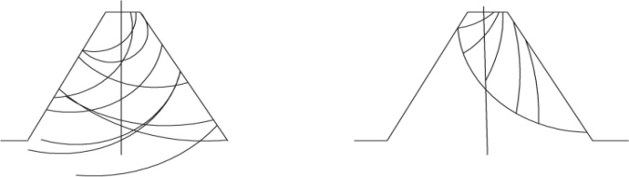
a) b)

Fig. 1. Zone of deformation during the shaping screws of two types:
a) with a lead-in chamfer; b) with a lead-in thread.

The field shown in Fig. 1,a) corresponds to the scheme of pressing in wedgebar container and the solution of the problem of plasticity theory on the compression of metal between two equal sloping slabs. In this case, are formed at the same time both sides of the thread profile, that corresponds to thread formation with shut-off cone when the neighboring protrusions of the conical part of the screw deepen into the metal and increase the height of the shaped round on both sides.
Another picture of the slip-line field corresponds to the case of thread formation when the thread fully deepen into the metal of the case during one revolution of the screw. In this case, the formation of the profile produced by turn and this process is similar to the broaching to the flat wedge punch.
These cases are typical of a standard thread profile with a normal groove. From the pictures of the fields of slip lines can be seen that the plastic region spreads to the entire cross section of the thread, it is a intensive flow of metal in the middle part of the profile. Therefore, the metal fills the entire flute area of the screw and the parameters of the "crater", is relatively small.
Such processes, as presswork (direct and reverse), broaching, drawing, reducing with the same area of inhomogeneous plastic flow. Formally they can be described by the circuit shown in Fig. 2.$\left[1\right]$
The main parameters of these processes are:
- The compression of the workpiece $R={H_{1}}/H$ ,
H and H₁ – the thickness of the workpiece before and after compression;
- γ – the angle of the matrix.

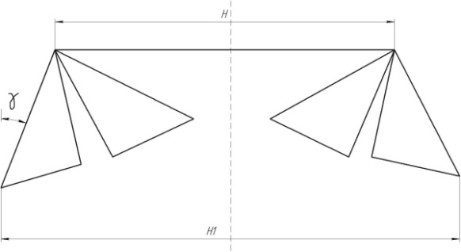
Fig.2 Typical diagram of the pressing.

It is known, if the fields of slip lines covers the entire flute area of the screw, then the relation is valid:

If R exceeds the calculated from the condition of extreme load value, the solution has other kind, namely such that it corresponds to the solution of the problem in deepening hard wedge. For thread rolling forming screw γ=30⁰ then the calculated value is H₁/H=1/2.$\left[2\right]$
Parameters of the screws thread with a wide groove is such that the ratio H1/H is much greater than 0.5. So the picture of the fields of slip lines for plastic region that is formed by the screws with a wide groove, meets the case of the introduction hard wedge in rigid-plastic region (Fig.3). Introduction hard wedge in rigid-plastic region is an example of unsteady flow where there is a geometrical similarity – the independence of the shape of the plastic region from the penetration depth t hard wedge. To increase the penetration depth of plastic area only increases in magnitude without changing shape.
Fig.3. Scheme of implementation dentara in rigid-plastic region.

Summary
Thus, the physical model that corresponds to the formation of threading screw with a wide groove can be model the introduction hard wedge in rigid-plastic region.

References
      - Полухин Н.И., Воронцов В.К., кучеряев В.В. течение металла при прокатке в условиях плоской деформации / Процессы пластической деформации и упрочнения/ московский институт стали и сплавов. – М.: машиностроение, 1988. – С.76-83.
      - Малинин Н. Н. Прикладная теория пластичности и ползучести. Учебник для студентов вузов. Изд. 2-е, перераб. и доп. М., «Машиностроение», 1975, 400 с.

